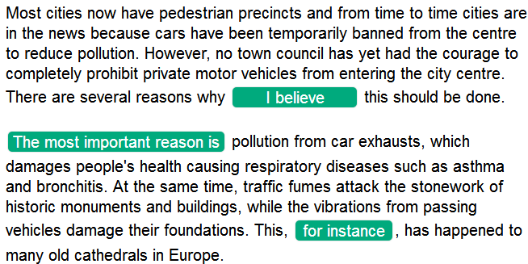

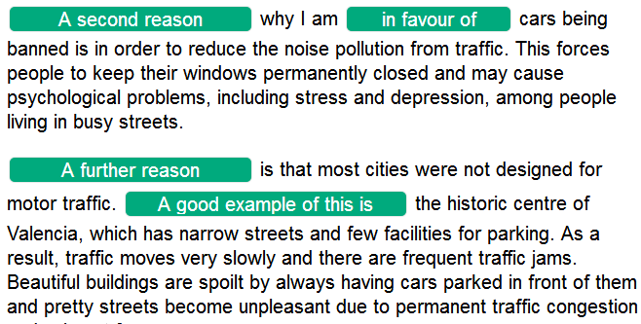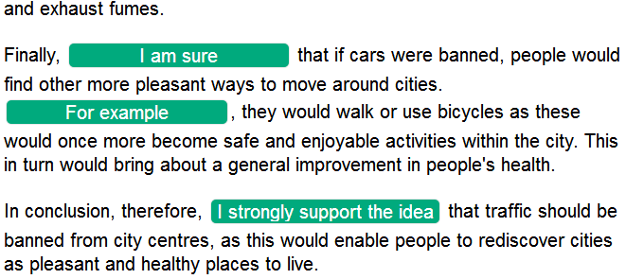

**1 Some people think that students should study in groups. Others, however, believe that students should study alone. Discuss both these views and give your own opinion.**

**2 Nowadays, television and the Internet have a greater influence on children's behaviour than their parents. To what extent do you agree or disagree?**

**3 Some people think that the purpose of education is to produce good citizens and workers. Others, however, believe that the purpose of education is to help young people achieve their personal ambitions. Discuss both these views and give your own opinion.**

**4 Some people believe that video games are harmless fun. Others, however, think that video games have a negative effect on players. Discuss both these views and give your own opinion.**

**5 Some people think that developments in artificial intelligence will have a positive impact on our lives. Others, however, argue that we are not prepared for a world in which machines are more intelligent than humans. Discuss both of these views and give your own opinion.**

**speech recognition, image recognition, household robots, self-driving cars, real-time recommendations, translation between languages**

**6 Museums and art galleries are not necessary because people can see the historical objects and works of art in these places on television or on the Internet. To what extent do you agree or disagree?**

**7 Some people think that the developments in agriculture, such as factory farming and creation of new types of vegetables, have brought us more benefits than problems. To what extent do you agree or disagree?**

**8 Some people think that advertising aimed at children should be banned. To what extent do you agree or disagree?**

**9 Some people think that increasing the number of police officers on the street is the only effective way to reduce crime. Do you agree or disagree?**

**10 Governments should pay for people’s education and health care. To what extent do you agree or disagree?**

**11 International travel is cheaper and more convenient than ever. Do the advantages of this outweigh the disadvantages?**

**12 More and more people today live in small nuclear families rather than in large extended families. Do you think this is a positive or negative development?**

**13 Some people believe that instead of trying to prevent climate change, we should find ways to live with it. To what extent do you agree or disagree?**